**Psych 63: Facial Electromyograms (EMG) and Emotion**

In front of you, you will find the iWorx recording module and a computer loaded with a program called LabScribe that will be used for data acquisition. You will need to setup the equipment and connect it to the laptop (see Figure 1), which you will be shown how to do. Once the equipment is hooked up, follow the directions below to properly hook up a participant and use the recording software to record and save data.

../../../../Downloads/Psych43_GSR_fEMG_HR_SetUp_Labeled.pdf

*Figure 1. The recording setup, labeled.*

**SET-UP**

1. Choose a person to be the Participant and a person to be the Computer Operator.
2. The Participant will be hooked up to electromyograph (EMG) electrodes on their face, galvanic skin response (GSR) electrodes on their fingers, and a plethysmograph (pulse recorder) on their thumb.
3. To begin, start attaching the EMG electrodes. Locate the muscles of the face over which the recording electrodes will be placed. These muscles can be located by frowning and smiling and noting the areas of the face where the muscles are tense (see Figures 2 and 3).
4. Use an alcohol swab to clean and scrub the areas where the electrodes will be placed. Let the areas dry before attaching the electrodes.

*Note*: If the Participant cleans their skin with the alcohol pad this can dry the skin on the hand which may impact GSR recording. The Participant will need to apply GSR gel to their hand.

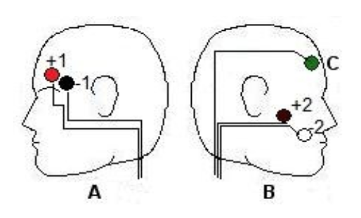

*Figure 2. The location and coloring of the recording electrodes.*

1. One pair of recording (red and black) electrodes will be placed over the Corrugator supercilli muscle just above the left eyebrow. The electrodes should be placed as close together as possible.
   1. The first electrode (red) is placed above the center of the eyebrow. This electrode should be placed as close to the eyebrow as possible while also being careful to avoid the Participant’s hair (it can be pulled out by the adhesive!).
   2. The second electrode (black) is placed directly next to the first electrode and to the outside of the eye, towards the hairline.
2. The second pair of recording electrodes will be placed along the Zygomaticus major muscle along the right cheek. Trace an imaginary line between the corner of the mouth and the indentation at the top of the ear. The electrodes should be placed as close together as possible on this line.
   1. 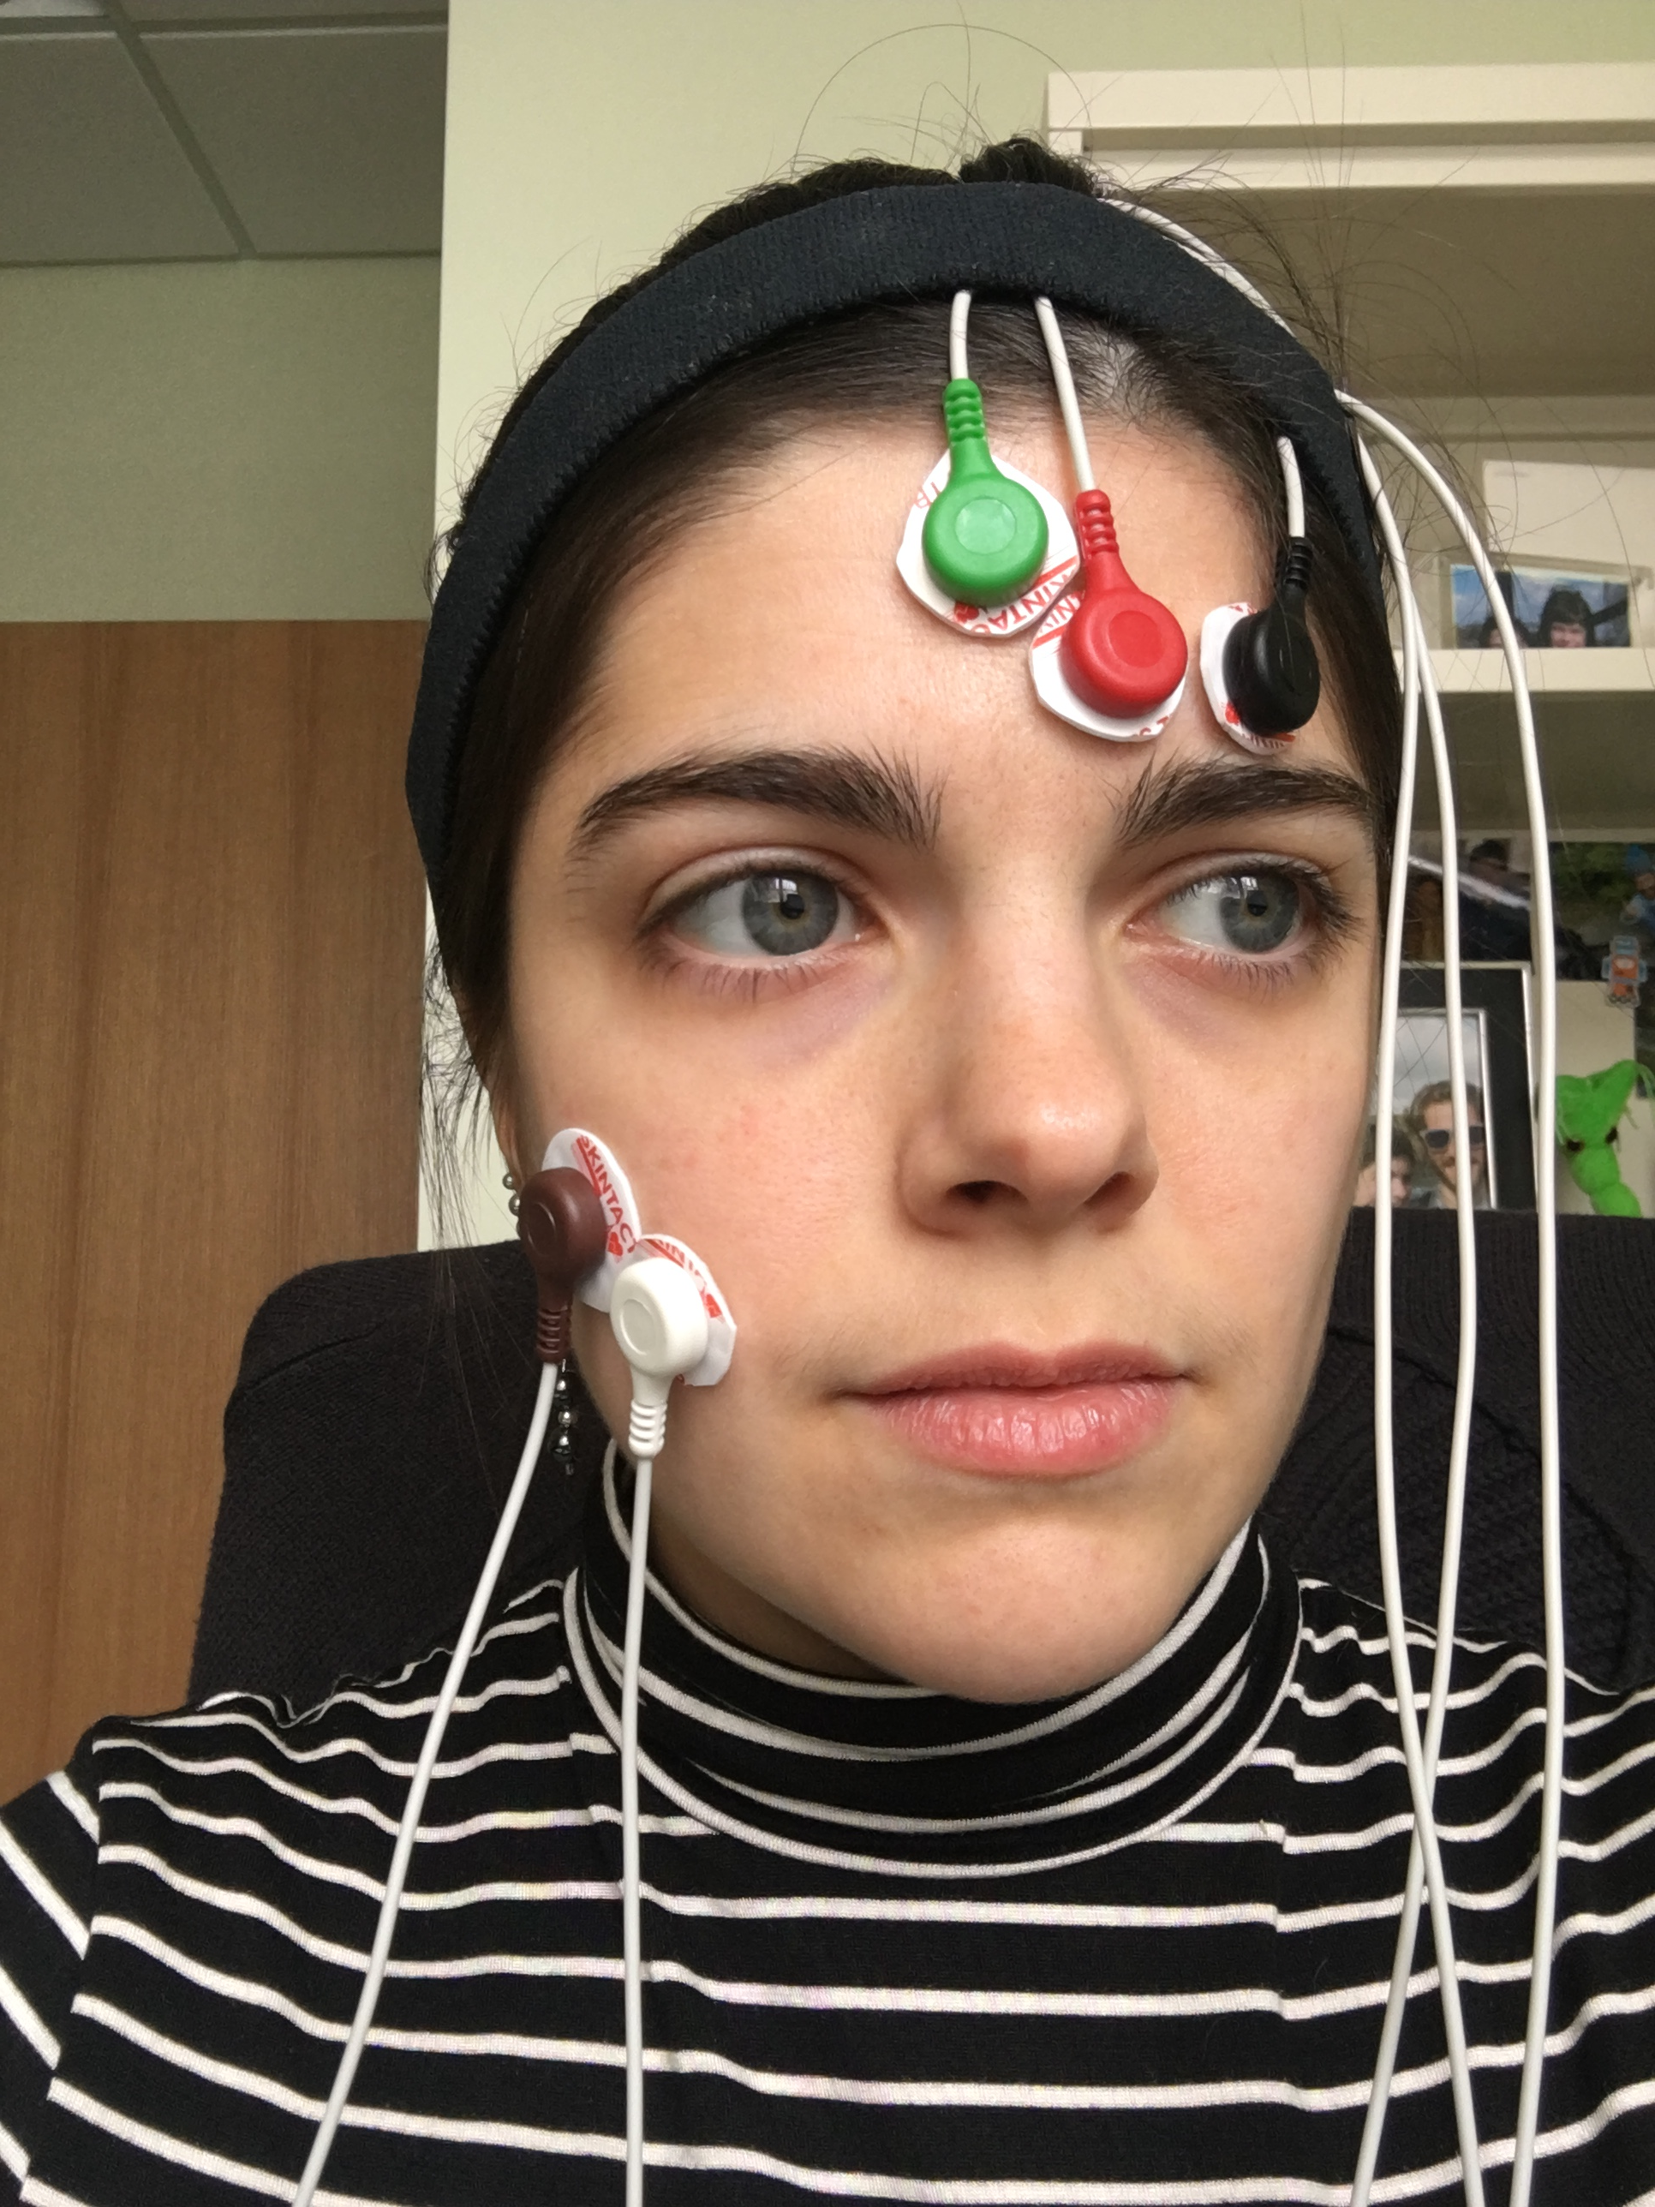Place the first electrode (brown) directly in the center of this imaginary line (on your cheek).
   2. Place the second electrode (white) immediately next to the first, closer to mouth along the imaginary line.
3. Place the fifth electrode (green), used as the ground, anywhere on the forehead.
4. Drape the cords of the forehead electrodes (brown, white, and green) over the top of the head. Use the adjustable headband to hold the wires from these electrodes on the Participant’s head so that they don’t fall in front of the Participant’s face.

*Figure 3. Placement of EMG electrodes on the face.*

1. Now, you will place the GSR electrodes. To begin, have the Participant remove all jewelry from their wrist and hand and then place one hand (left or right) on the table next to the iWorx module.
2. Attach the GSR electrodes to the volar surface (the side with the fingerprints) of the pointer and ring finger of the Participant's hand. The electrodes should be placed at the base of the finger, not at the tip (see Figure 4), and the wires should extend out towards the tips of the fingers. Take care that the electrical wires leading to the electrodes are not tangled and that the wires are hanging freely. The Velcro should be snug, but not uncomfortable. It does not matter which color electrode goes on which finger.
   1. Note: Make sure the Participant’s fingers are not too cold or dry. If the Participant’s hands are very dry apply GSR gel to their hands to moisten the skin. Don’t use too much gel and rub in the gel as you would hand lotion.

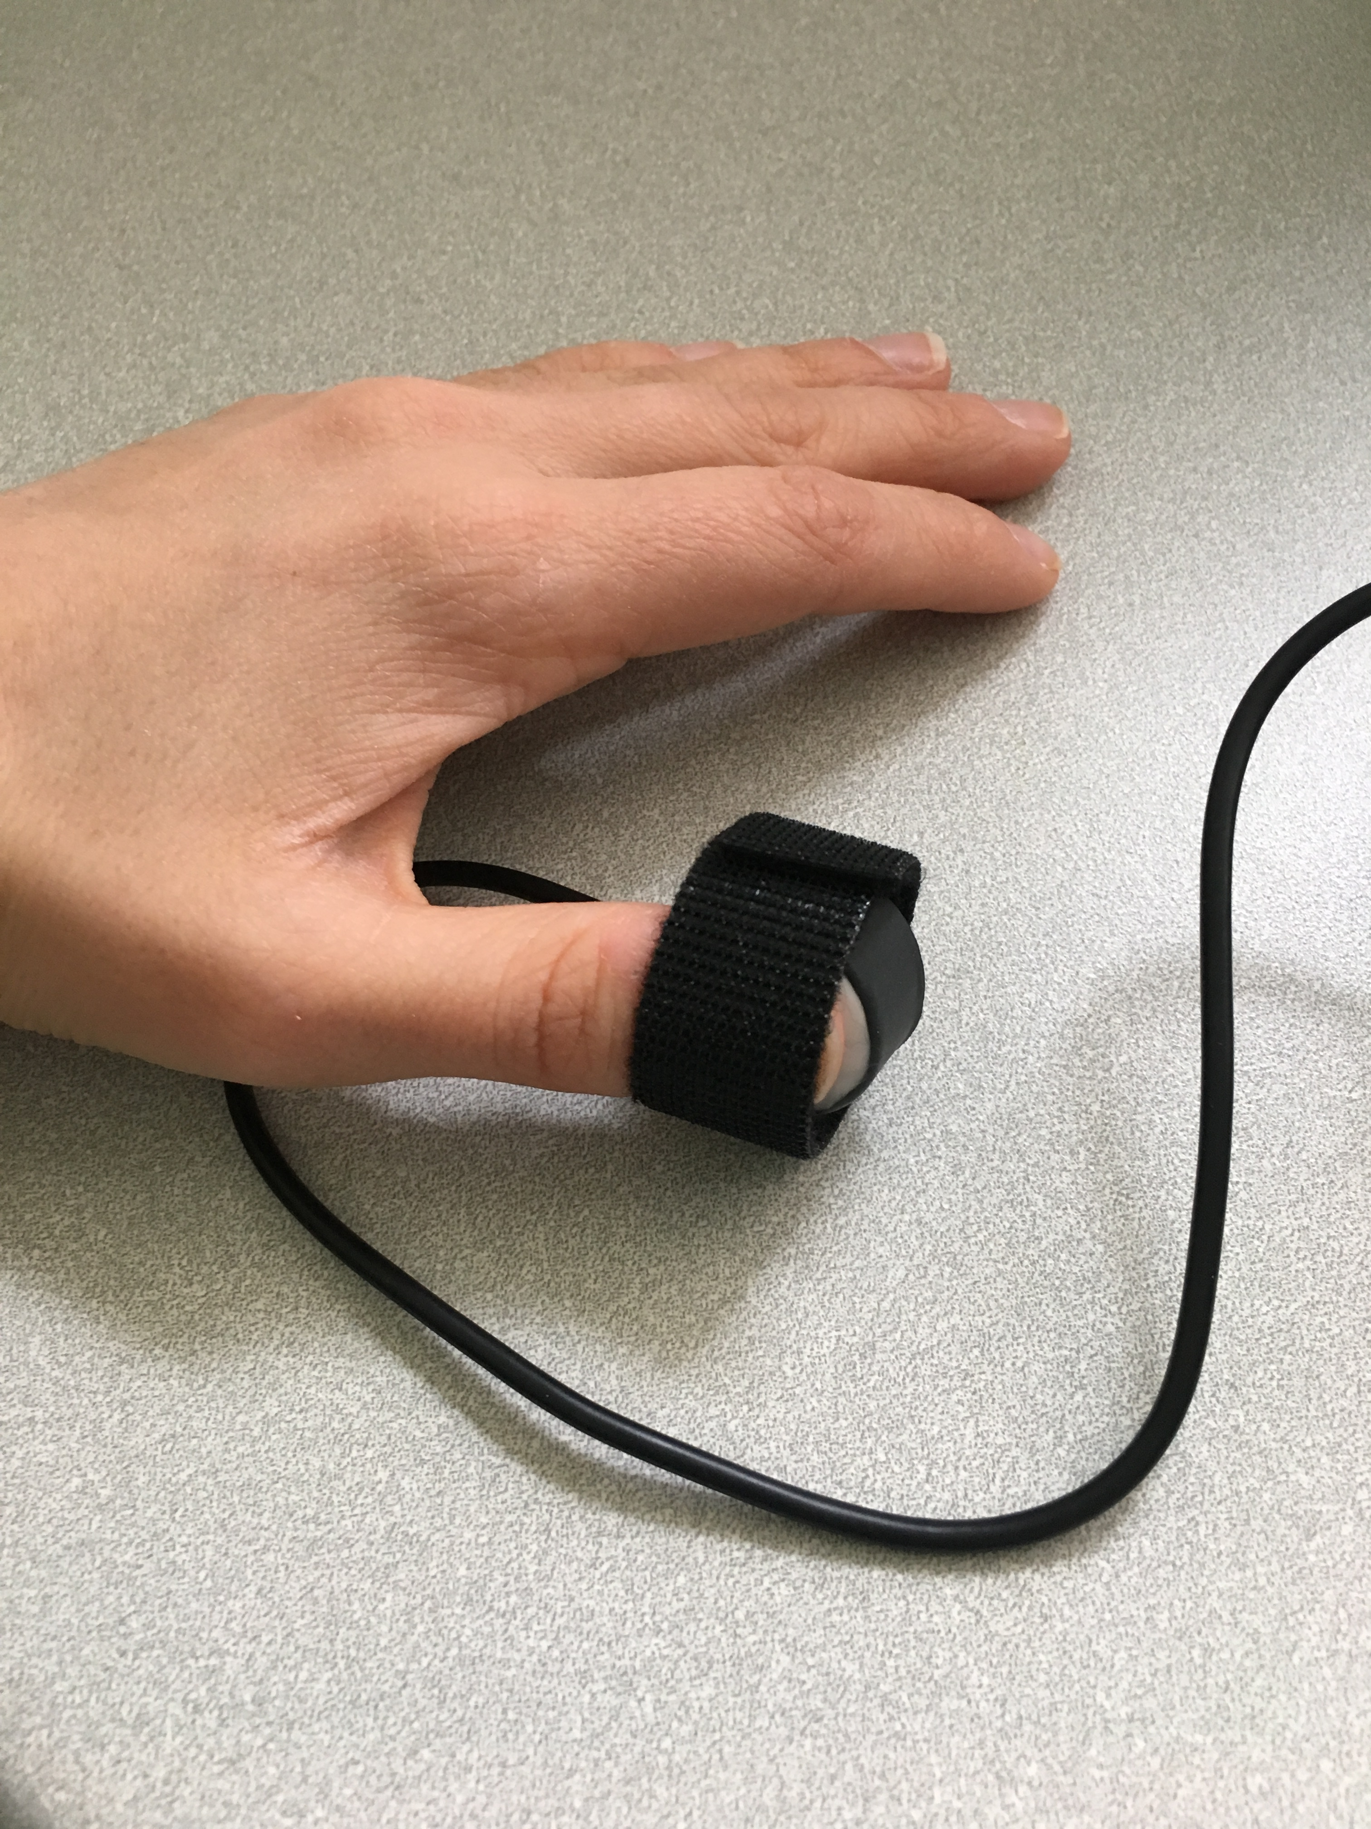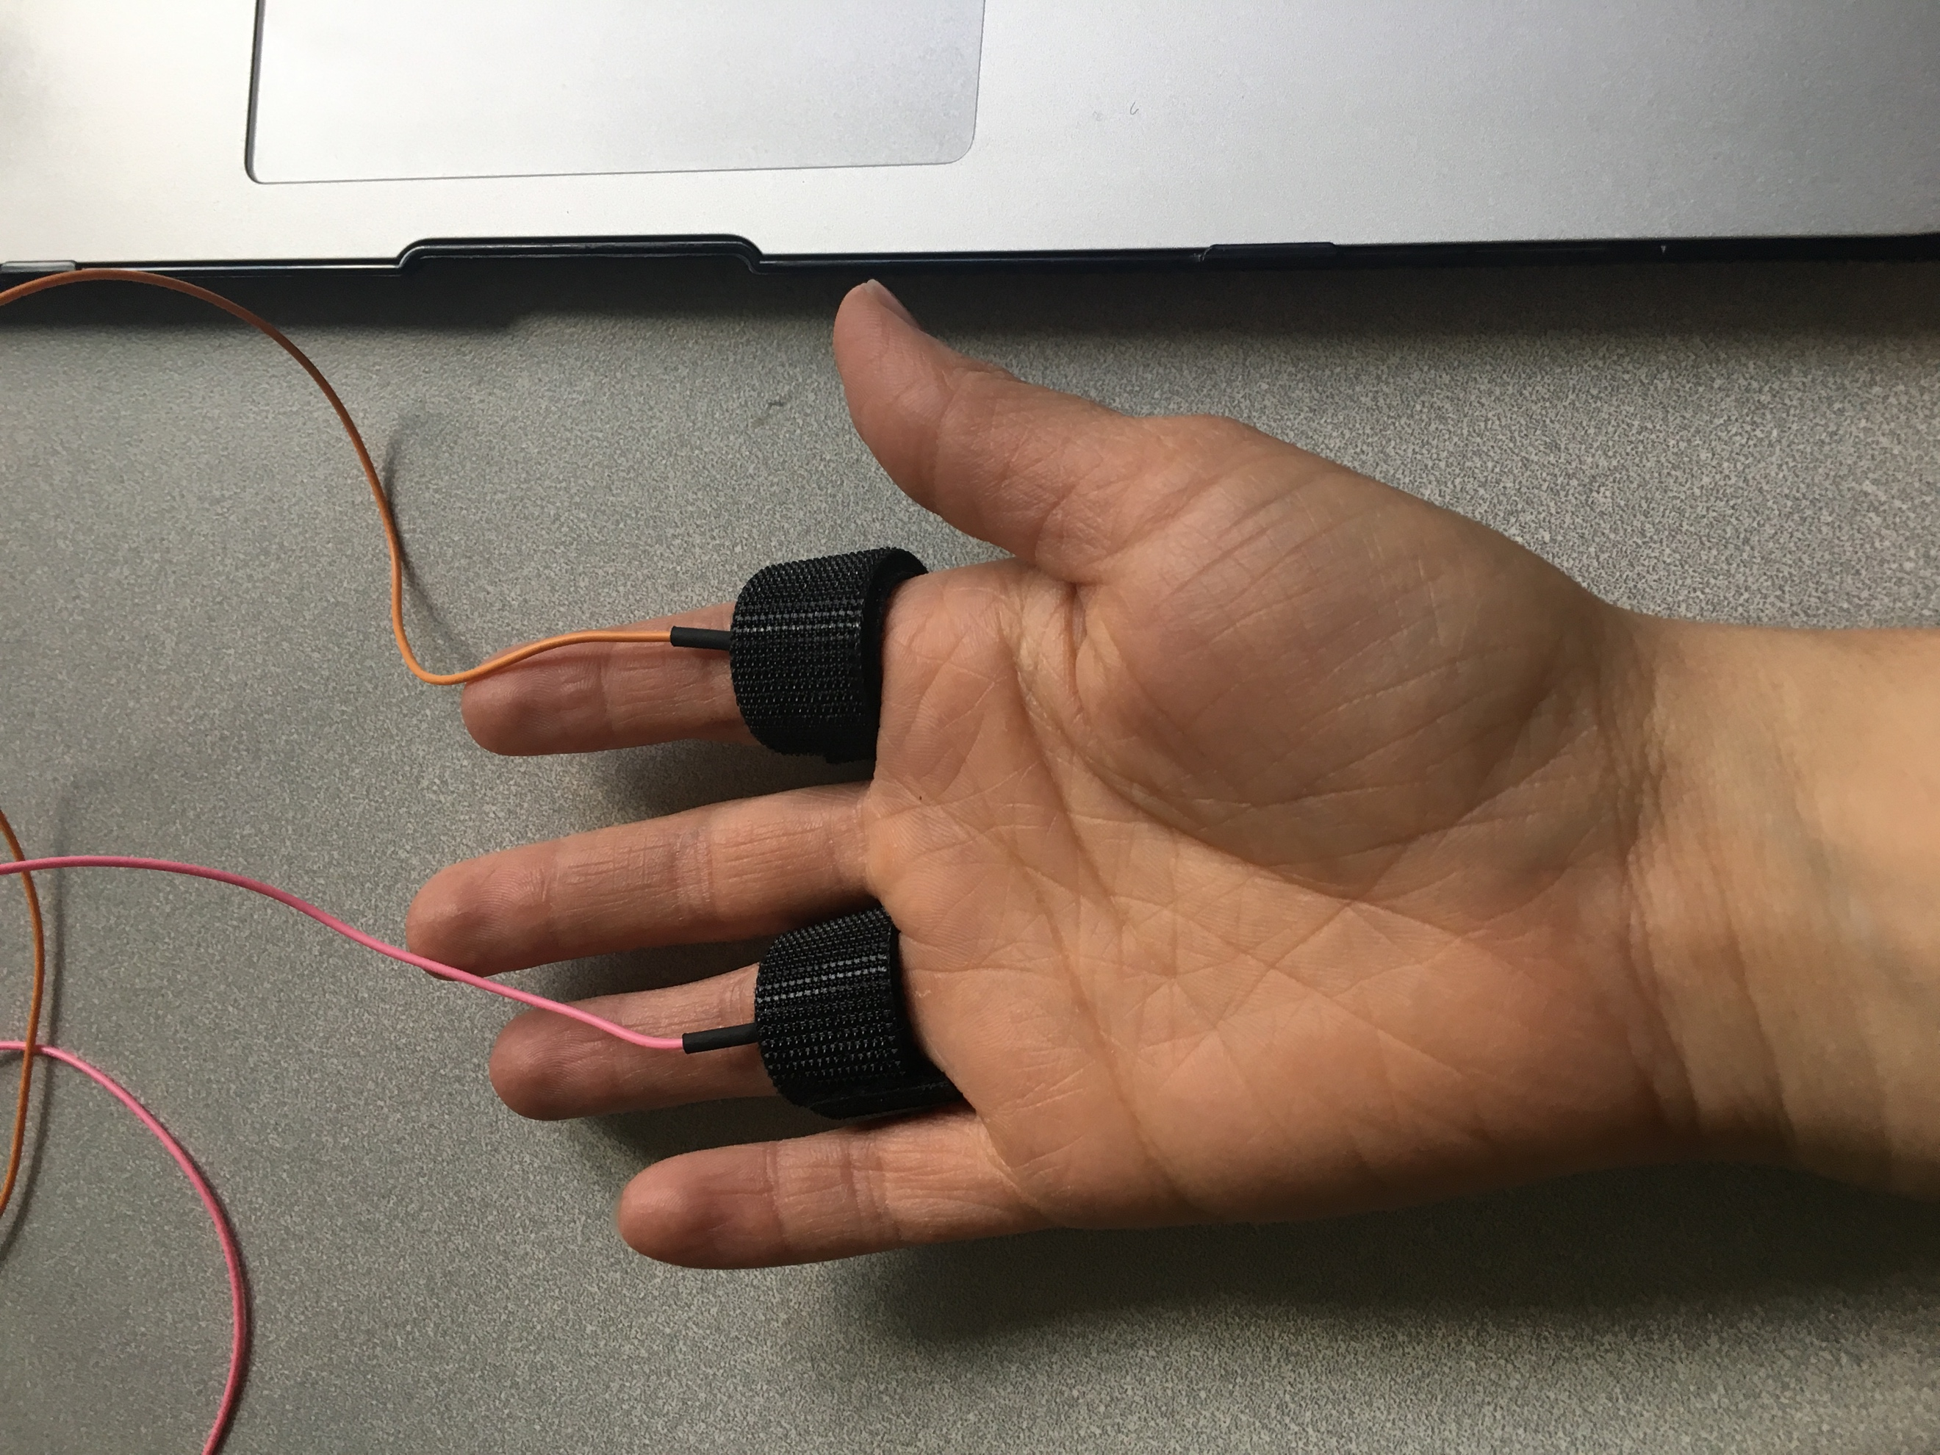

*Figure 4. Placement of GSR electrodes. Figure 5. Placement of the plethysmograph.*

1. The Participant should keep their hand resting palm up by the iWorx box, avoiding any extra pressure on the electrodes. The Participant should not move their hand during the recording as this can introduce large artifacts in the data.
2. Finally, attach the plethysmograph (pulse recorder) to the thumb of the Participant’s hand that DOES NOT have the GSR electrodes. Place the plethysmograph on the volar surface (the side with the fingerprints) of the tip of the participant’s thumb (Figure 5). The Velcro should be snug, but not uncomfortable.
   1. The pad of the thumb should be flat on the white surface of the plethysmograph. If the thumb does not fully contact the sensor, the recording can be inaccurate.
   2. If the signal is weak or absent, place the plethysmograph on any other finger.

**EXPERIMENT**

1. Before the recording begins, the Participant will sit quietly with their hands resting on the table and their mouth neither smiling nor frowning.
2. The Computer Operator should check the sequence bar (see Figure 6) to make sure the sequence is “Off”. The sequence is the order in which visual stimuli are presented to the Participant. You do not want them viewing stimuli when you start the system to calibrate signal quality.
3. Hit “Record” and the data will begin scrolling across the screen (see Figure 6).
   1. The top channel, labeled “Corrugator supercilli muscle” is displaying the electromyograph (EMG) of the muscle above the eyebrow (black and red electrodes) measured in millivolts.
   2. The second channel, labeled “Zygomaticus major muscle” is displaying the EMG of the cheek muscle (brown and white electrodes) measured in millivolts.
   3. The third channel, labeled “Pulse” is displaying the raw pulse data from the plethysmograph measured in volts.
   4. The fourth channel, labeled “Heart Rate” is displaying instantaneous heart rate calculated from the Pulse channel reported as beats per minute - bpm.
   5. The fifth channel, labeled “GSR” is displaying the galvanic skin response or skin conductance level (SCL) measured in µSiemens.

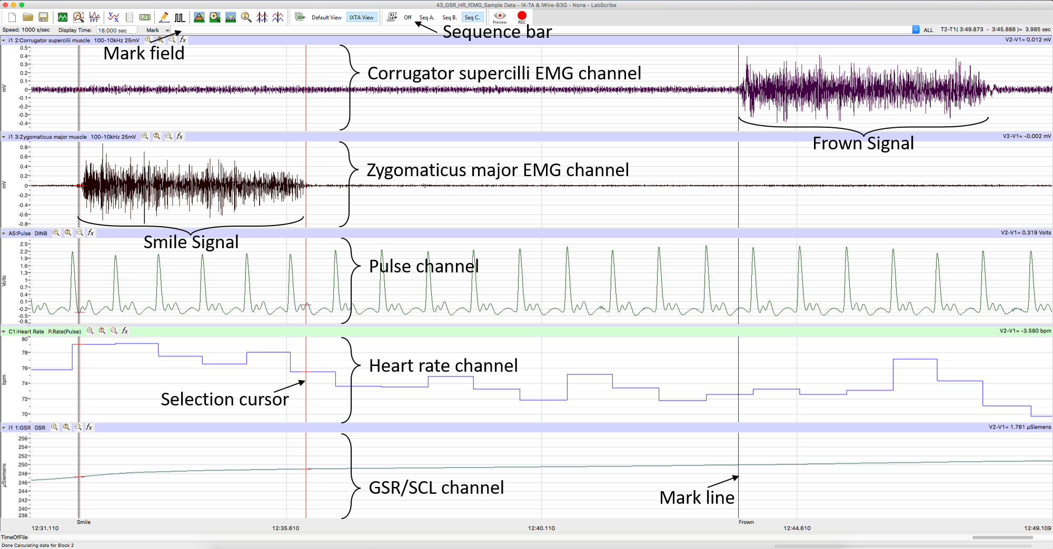

*Figure 6. Example data recorded in LabScribe, labeled.*

1. To scale the channels, click the “Autoscale all channels” button (see Figure 7). This will change the zoom of the y-axis (vertical axis) on each channel to optimally display the data. If you have any artifacts due to movement, you will need to wait until the section of the data containing the artifact has moved off the screen and *then* hit “Autoscale all channels” again to have an appropriate view. *You can hit this button at any time to more accurately see the data*. *There is an autoscale button for each graph to the right of the graph label that can be used to scale only that graph.*
2. You may also need to change the scale of the x-axis (horizontal axis) by clicking the “Half display” or “Double display” buttons (see Figure 7) to speed up or slow down the scroll rate of the recording, respectively. You will notice that the time scale at the bottom of the screen changes when you do this.

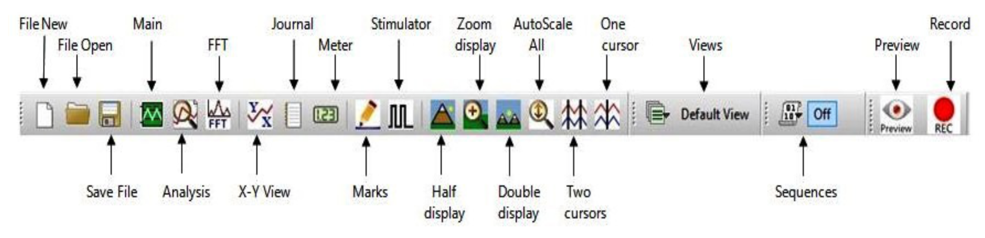*Figure 7. The LabScribe tool bar labeled.*

1. Figure 8, shows an example trace of electrical (60 Hz) noise in the EMG. This can result from poorly attached or placed electrodes, tangled wires, and/or other connection problems. If you see noise in your data, try re-securing the electrodes, untangling the EMG wires, change the zoom of your window, or ask for help.
   1. Be sure to compare a “real” signal, resulting from actual facial movements, to what seems like it could be noise. The “real” signal should be much larger than the noise (this is called having a “good signal-to-noise ratio”).

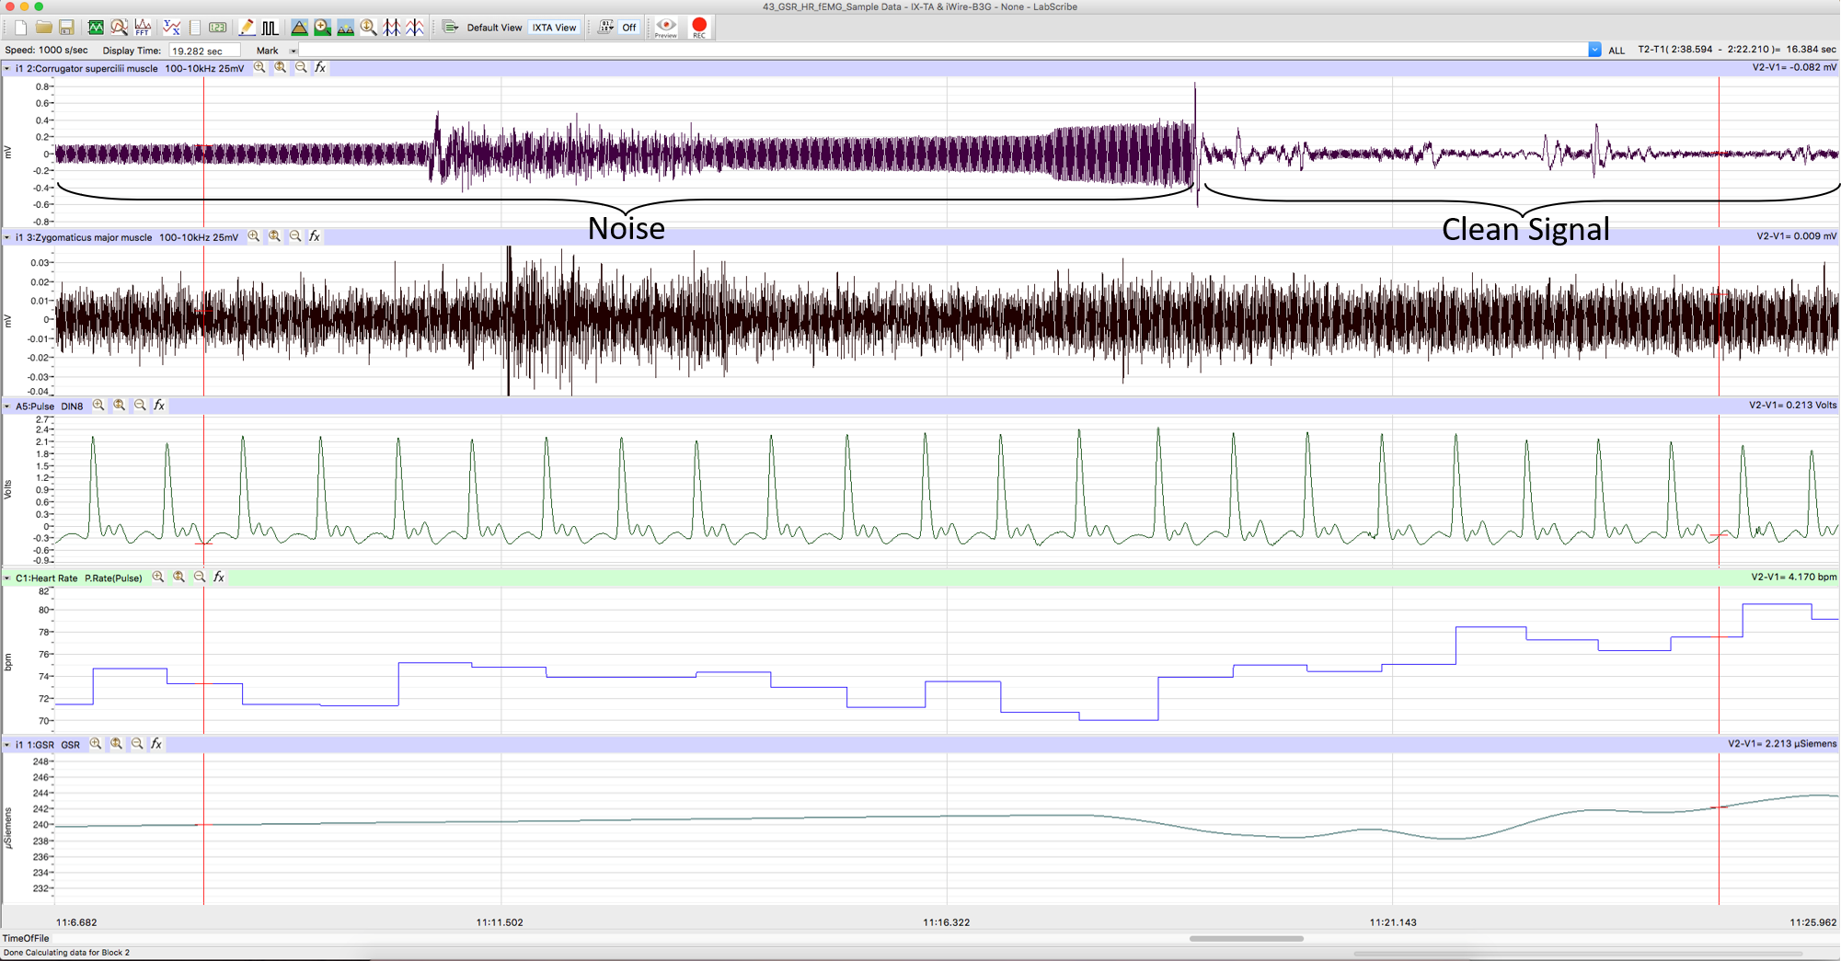

*Figure 8. An example of noise disrupting the EMG recording.*

1. Once all signals are being detected accurately, type “Smile” in the “Mark” field to the right of the “Mark” button. Instruct the Participant to smile and hold for 5 seconds. Simultaneously hit return/enter to add this label to the data (see Figure 6 for example data).
2. As the Participant is smiling, type “Neutral” in the “Mark” field to the right of the “Mark” button. Once the Participant stops smiling, hit return/enter to add this “Neutral” label to the data and record for 5 seconds.
3. Type “Frown” in the “Mark” field to the right of the “Mark” button. Instruct the Participant to frown and hold for 5 seconds. Simultaneously hit return/enter to add this label to the data.
4. As the Participant is frowning, type ““Neutral” in the “Mark” field to the right of the “Mark” button. Once the Participant stops frowning for 5 seconds, hit return/enter to add this label to the data and record for 5 seconds.
5. Repeat steps 19-22 to ensure good examples of neutral, smile, and frown faces. Once you have recorded two cycles of smile-neutral-frown-neutral, hit “Stop” to end the recording.
6. The Computer Operator should then click in the sequence bar the “Seq Psyc63”. This will activate the emotional visual stimuli that will be presented to the Participant during recording.
7. To begin the experiment, make sure the computer monitor is directly in front of the participant, so they can easily see the visual stimuli that will be presented, and they are sitting in a neutral position.
8. Click “Record” and the software will automatically present 20 images (10 positive and 10 negative) in pseudorandom order.
9. Once images have stopped being presented the Computer Operator can click “Stop” to end the recording.
10. To save the data, select “Save As” in the File drop-down menu. Name the file with your Participant’s initials, EMG, and the course number (i.e., “ABC\_EMG\_Psyc63”). Save the file to a folder located on the desktop called “Psyc63”. Designate the file type as \*.iwxdata. Click on the “Save” button to finish.
11. The data can also be exported for analysis using custom software. Select the File drop-down menu and select “Export”. Export the data as MatLab (\*.mat) or Text (\*.txt) to the same folder as the .wxdata file from step 28.
12. You can also export the event markers for when different images were presented to the participants. Select the “View” drop-down menu, select “Marks”, and select “Marks” again. Click on the export button and export all Marks to the same location as the data.